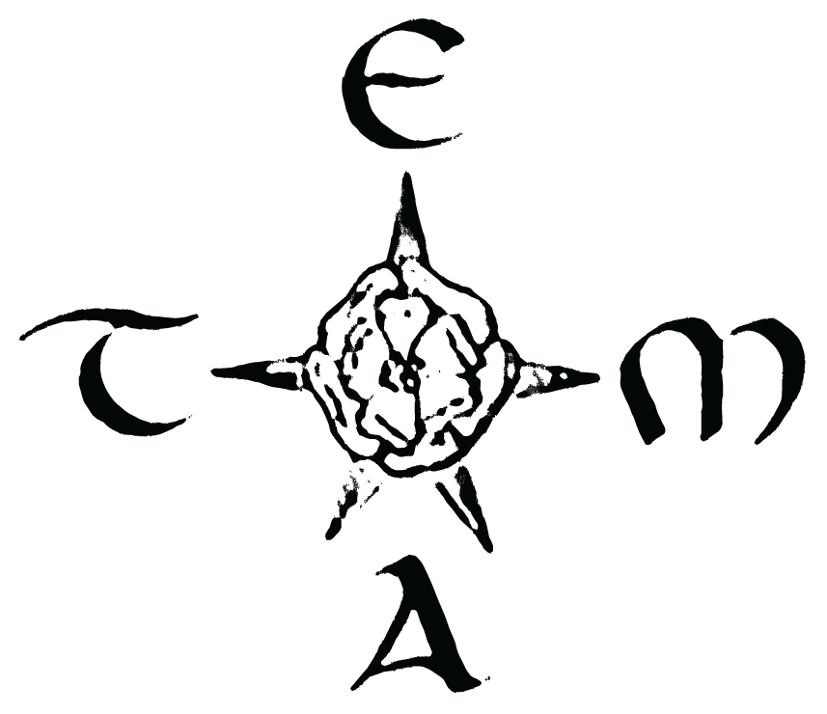

29th Annual Conference
of the
Texas Medieval Association

October 18-20, 2019

Send all proposals to texasmedieval@gmail.com

TEMA Proposal Form Deadline: September 1, 2019

Session Paper

Paper Title
(if applicable)

Session Title
(if applicable)

Session Type
Papers Roundtable Workshop Performance

Title

Name

Affiliation

E-mail

Audio-Visual Equipment

I need A/V equipment, which includes a computer, projector, and speakers.

I do not need A/V equipment

Privacy

I do not want my presentation or image shared on social media.

I do not want to be added to the TEMA mailing list.

Session/Paper Abstract, not to exceed 250 words

Send all proposals to texasmedieval@gmail.com

